MediMedium Access Control CSMA/CA Binary Countdown Protocol for SCADA Application

¹K.U.Prateek,²B. Dinesh Ballullaya, ³R. L. Chakrasali, ⁴S.S.Navalgund, ¹PG Student, ^{2,3}Professors, Dept.of Electrical and Electronics Engineering, ^{4,}Asst.Prof.Department of Electronics & Communication Engineering SDM College of Engineering and Technology, Dharwad ¹kuprateek@gmail.com,²pratisatu@yahoo.co.in,

Abstract: This paper discusses a novel approach toaccess the medium using CSMA/CA (Carrier Sense Multiple Access with Collision Avoidance) protocols for SCADA (Supervisory Control And Data Acquisition) system employed in power systemoperation and control. This method offers superior performance over the existing practices of accessing medium using CSMA/CD protocols. The proposal makes use of binary countdown method with modifications. The requirements of SCADA system such as reliability and real time operation can be achieved by fast data transmission and prompt delivery. In this work, a program is written and the procedure is run to allocate the channel considering the priorities of the RTUs (Remote Terminal Units) and the type of data to be transmitted such as normal data for archival and event triggered data for operation control. The program uses generic statement and is applicable to a system having a MTU (Master Terminal Unit) and any number of RTUs. The results obtained by running the procedure show its novelty. Further, a Moore finite state Moore machine is designed and a VHDL model is developed.

Key words: SCADA, Medium access, protocols, MTU,RTU, procedure.

I. INTRODUCTION:

SCADA is real time data management of production operations using efficient control paradigms to improve Quality, Plant & personnel safety and reduction in cost. The use of a SCADA for operating power system

is supported by a distributed architecture, with number of computers, called Remote Terminal Units (RTUs). These RTUs transmit data to a control center. The data is measure of electrical parameters which depict the state of the power system. The command signals are generated by the control centre and are communicated to RTUs for equipment control. Taking into account the large number of equipment and their geographical dispersion, the communication with the control center usually uses multiplexed lines of narrowband channels. In order to reduce the total number of required channels, several RTUs are usually connected to each line, sharing the channel’s resources. In any broadcast network, the key driver is how to determine who gets to use the channel when there is contention for it. The protocols (a set of rules being mutually agreed upon by the communicating parties) are in use to determine who goes next on a multi access channel and is taken care of by a sub layer of data link layer called MAC sub layer. The procedures run to seize the physical medium for data transmission in coordinated way is called MAC protocol.

II.SCADA SYSTEM ARCHITECTURE:

A typical configuration of SCADA system Architecture used in power system is shown in fig.1.
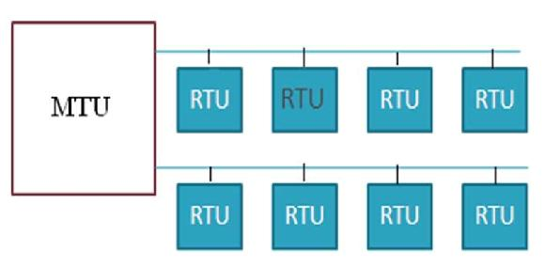

Fig.1 SCADA system architecture

The Master terminal unit (MTU) is equivalent to a master unit in master/slave architecture. The MTU presents data to the operator through the HMI, gathers data from the distant site, and transmits control signals to the remote site. The transmission rate of data between the MTU and the remote site is relatively low and the control method is usually open loop because of possible time delays or data flow interruptions. The Remote terminal unit (RTU) functions as a slave in the master/slave architecture sends the received control signals to the device under control, acquires data from these devices, and transmits to the MTU. An RTU may be a PLC or PC. The data rate between the RTU and controlled device is relatively high and the control method is usually closed loop. The data communication uses the Internet, wireless or wired networks, or switched public telephone network.

The SCADA protocols have been developed for power networks keeping in view that it must be suitable for real time, reliable operation and tolerance under emergency situations as delay in communication cannot be affordable. Further, the protocols should also consider the through put of the channel.

There are a large number of protocols used in SCADA systems. These have been provided by the system manufacturers or by the users. Nowadays SCADA system is migrating from customized platform to standardized PC and windows platform. The protocols are developed taking OSI model as reference, a stack of seven layers. While developing protocols for power systems, one or more of these layers are unused/not present. In contrary, EPA model (Enhanced Protocol Architecture) specifically proposed by the IEC (International Electrotechnical Commission) [3] for the telecontrol of power systems is having three layers viz Physical layer, Data link layer and application layer. In both approaches, the control procedures for the Medium Access Control are in the lower sub layer of the Data Link layer. The problems of the Medium Access Control encountered in LANs are very similar to those of SCADA system. Thus, one can make good use of the results and experiences from the LANs.

III. MEDIUM ACCESS CONTROL

PROTOCOLS:

There are many medium access control protocols to access the physical medium and

are classified into three categories viz selection (polling, token bus and token ring), Contention (ALOHA, CSMA and CSMA/CD) and Reservation. Selection techniques are based on the transmission turn goes on in an ordered way, around a set of computers connected to the same physical medium. In contention technique, stations contend among them for the physical transmission medium, producing collisions. In CSMA/CD protocol, each node willing to transmit (control center and RTUs), has carrier sense (CS) feature. However, due to the propagation delay through the physical medium, two or more nodes could transmit at the same time, producing a collision. A node also has collision detection (CD) feature and aborts its transmission and waits for a random period of time before making next attempt.

Reservation techniques are based on splitting the transmission medium into different sub-channels, using physical mechanisms such as Frequency Division Multiplexing and Time Division Multiplexing and are used to establish point to point virtual connections between the stations within the networks and are rarely used in LANs.

The number of RTU’s, the transmission speed, and the commuting delay are the parameters used to determine the performance of protocols. In general the efficiency of the above protocols is quite low, typically between 60%-70%[1].

IV. COLLISION FREE PROTOCOLS:

The desirable properties of SCADA systems are reliability, real-time response and tolerance of emergency situations. The existing protocols have the limitation of channel access delay and collision, which may not felicitate the determinism. These limitations can be overcome by employing collision free protocols such as bit map protocol, limited contention protocol, binary countdown protocol etc. to improve the situation.

In this work a procedure is developed using C language for Binary countdown collision free protocol. The Program is generic that will accommodate a MTU and any number of RTUs. Further, a Moore finite state machine is designed which is the hardware version of a procedure. The hardware is simulated using VHDL to validate the design of hardware.

The binary countdown Protocol: All the stations contending for the channel are assigned with unique address and are assumed to be same length. The stations are attached with priorities to get the channel. The bits in each address position from different station are BOOLEAN ORed together. To avoid conflicts an arbitration rule is applied. As soon as the station sees that a high order bit position that’s 0 in its address has been over written with 1, it gives up. This process continues and the station having address of higher number will get the channel for data transmission. The working of the protocol is

illustrated in figure 6. It has property that higher number stations have a higher priority than lower numbered stations. However, one must be optimistic that all the higher address stations need not have data to communicate all the time, thus, stations of lower numbered address will also have fair chances of sending the data. The channel efficiency of this method is d/(d+log2N) and efficiency is very close to 100%.
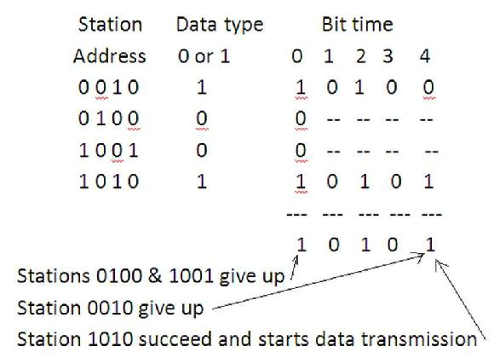

Fig. 2 Modified binary countdown protocol

V.THE PROPOSED METHOD.

The proposed method suggests a novel approach of using the conventional binary countdown method along with the type of data that the RTUs are willing to transmit. The SCADA system is to acquire data and perform supervisory control. As applied to power systems, the RTUs gather data from field devices and transmit to the MTU. The MTU will process this data and generate accordingly the command signals and sends it back to RTUs to control the field devices. The data can be of two types in power system. The first one is the normal data that

is the parameters values within the specified tolerance and is used for determining the system status and sent for storage in the warehouse or repository. This data is also helpful in predicting the performance of the system. The second one is the critical or operational or event triggered data that is the parameters values exceeding the specified tolerance though not catastrophic but leads to system instability, if left unaddressed, Whenever RTU has critical data, that station is to be given priority to transmit. This is necessary because, based on this data MTU will generate command signals and convey to the RTUs to implement the control action to maintain the qualitative degree of the system stability.

The developed procedure takes care of the priority and the type of data that the RTUs willing to transmit. The algorithm goes like this:

- All RTUs have unique address of the same length

- All RTUs may have both critical and normal data to transmit

- The critical data is having higher priority over the normal data

- When channel goes idle, stations contend for the channel by inserting the priority bits of both the data and address

5. The RTUs having normal data to transmit give up contention though their address priority is higher

- Among the RTUs having critical data, the RTU with higher address priority is permitted to transmit data. Once it completes the data transmission then its

priority becomes zero thereby giving chance to other RTUs.
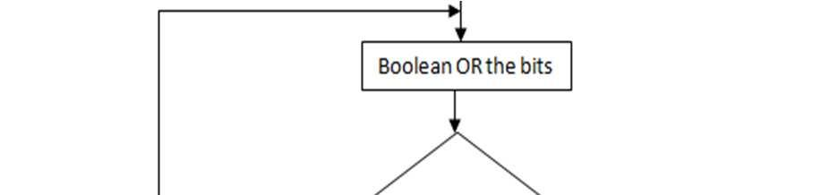
- This method of channel allocation repeats and there is no possibility of collision at all.

- After all channels complete the data transmission they wait for next contention slot and the procedure repeats.
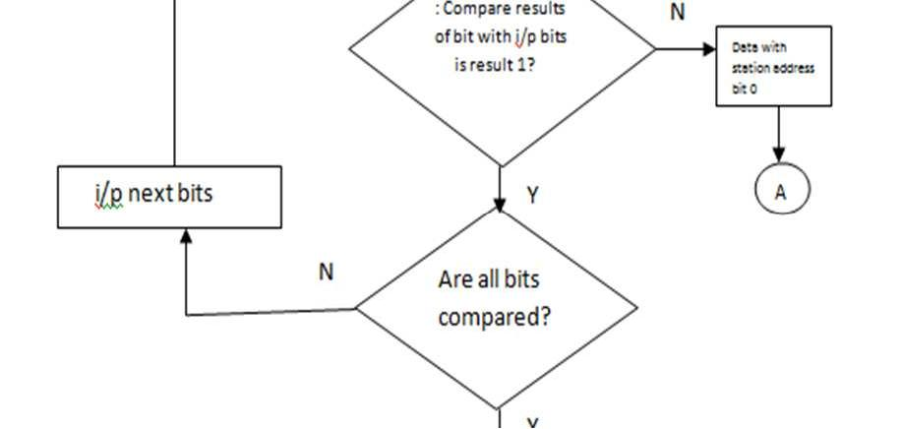
A flow chart for the collision free binary countdown protocol is given in fig.3.
Flow Chart:
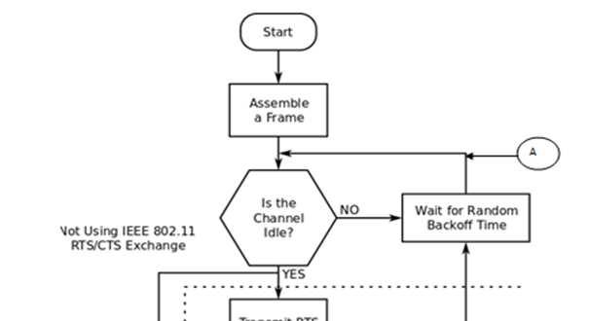

Fig.3 Flow chart for binary countdown protocol

Testing of the Procedure and Results: Theprogram developed is being run on a system consisting of one MTU and 5 RTUs. The RTUs send their address bits and type of data (n for normal data and c for critical data). The procedure takes these parameters as input arguments as shown in table 1. When the procedure is run, it will return the results as shown in table 2. The RTUs with critical data and as per their address priority are permitted to transmit. Once they release the channel their priority becomes 0 in the current contention and the remaining RTUs with normal data are permitted to transmit data based on their address priority.
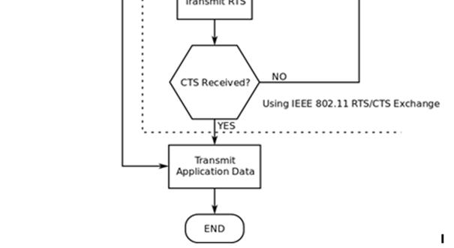
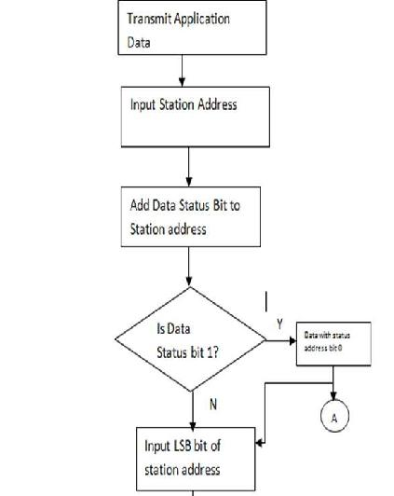

Table 1. Parameters pertaining to a system involving one MTU and 5 RTUs
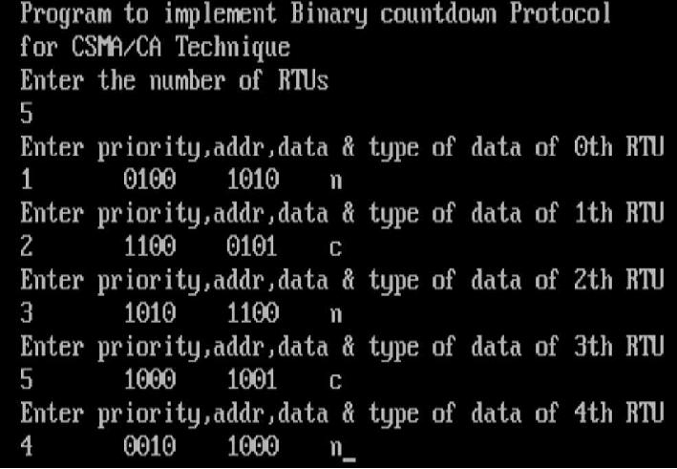

Table 2. Channel allocation to RTUs
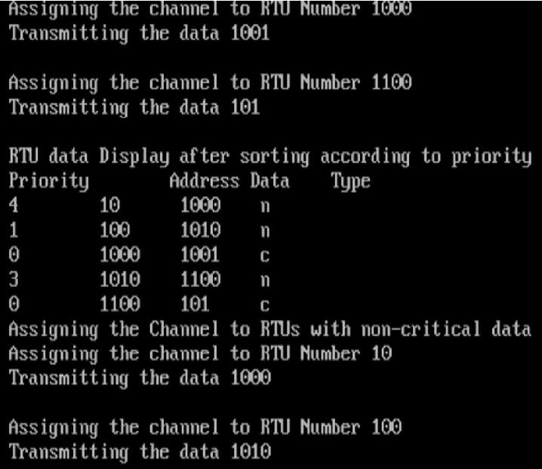
minimal expressions are derived using K-map. Further, the machine can be simplified by state reduction. The JK flip flops are used here, as it involves minimal external hardware. The finite state Moore machine is shown in figure 7
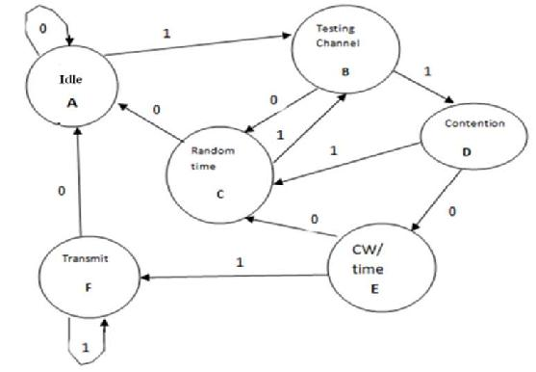

Fig.4 State diagram for binary countdown protocol
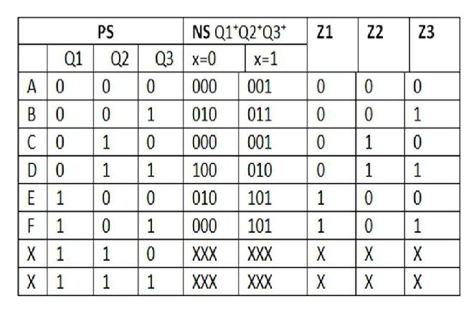

Fig.5 Transition table
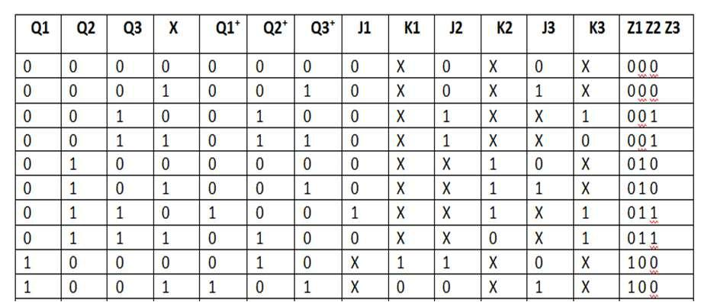

Design of Moore finite state machine: Astate table is developed for the channel allocation using binary countdown method and is shown in figure 4. The Moore finite state machine is synthesized by constructing the transition table and excitation table
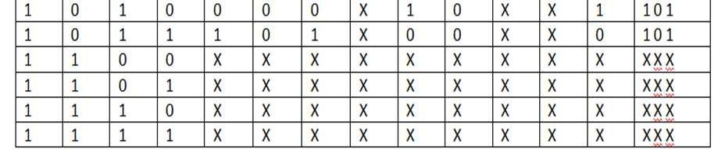
Fig.6 Excitation table
shown in figure 5 & 6 respectively. The

Fig.7 Moore finite state machine
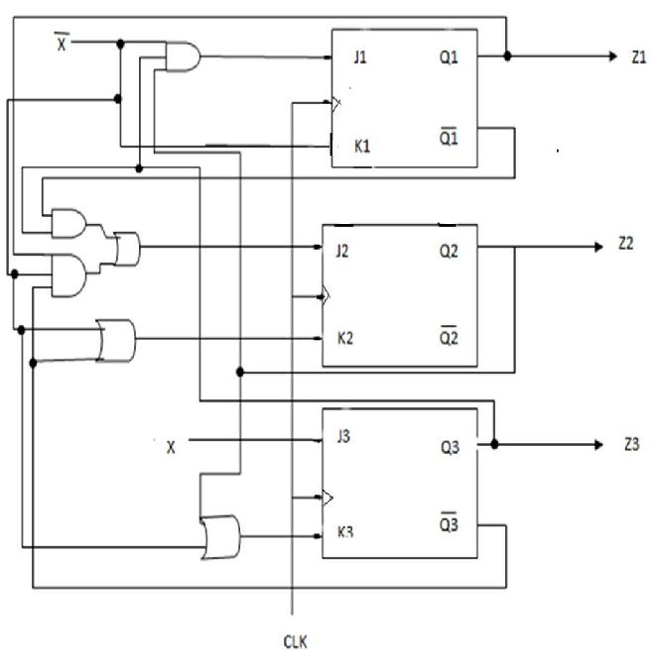
VHDL model for Moore finite state machine and Simulation results: The finitestate machine digital device is modeled using VHDL. The VHDL code is written using sequential style of modeling. The simulated model behavior is given in figure 8.
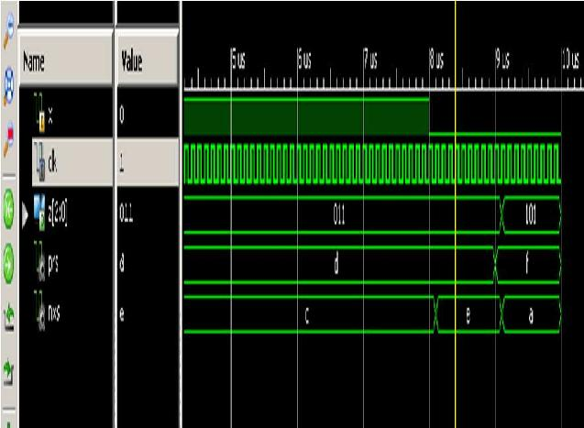

Fig.8 Simulation Results
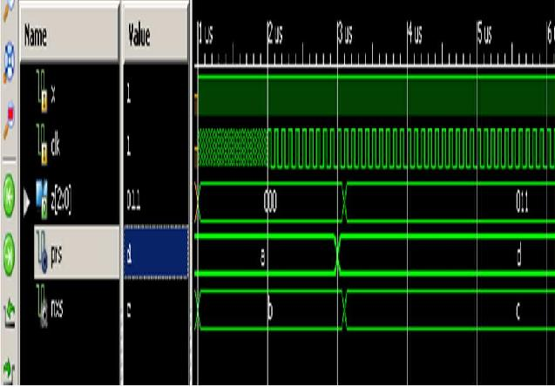
Results and Discussion: The results byrunning the procedure as listed in table 1 & 2, clearly indicate that the performance of this method of channel allocation is superior to the existing CSMA/CD protocols in terms of efficiency and free from collision. Further, the requirement of critical data to reach the MTU first for generating the command signals is met. This method is promising solution for channel allocation in real time operation and control of critical infrastructures employing SCADA to achieve benefits like production efficiency, reliability, personal and plant safety. The simulation results of the VHDL model also demonstrate a way of achieving the channel allocation without collision for smooth operation of critical infrastructures.

VI. CONCLUSION:

The modified binary countdown collision free protocol for medium access control, discussed in the paper is a unique and novel approach. It overcomes the problems of collision and lower efficiency associated with the existing CSMA/CD protocols. The results of the procedure reiterate that there

are no collisions and efficiency is 100%. The need of classifying data in to normal and critical data is emphasized in this work and the algorithm demonstrate that the critical data is transmitted first followed by the normal data and subsequently giving fair chance for all RTUs to seize channel and transmit data. The generic nature of the algorithm makes it suitable for SCADA applied to control any plant/process/system.

It is also demonstrated through simulation results of VHDL model that the protocol can be implemented through hardware. Hence, looking to the advantages of collision free Protocol and the results obtained confirms that it is the best MAC protocol for most of the SCADA applications.

REFERENCES:

- “The role of Medium Access Control Protocols in SCAD systems”, by Joaquin Luque and Isabel Gomez Dept of Electronic technology, University of Seville.

- International Organization for Standardization: “Information processing systems-Open system Interconnection-Basic Reference Model”, ISO Standard 7498, 1984.

- International Electrotechnical Commission TC%&,”Telecontrol Equipment and systems part 5.1 Transmission frame formats”, Internationa Standard, Geneva 1990.

- J. Luque, J.I. Escudero: “Measurement Transmission in Power Control Centers”, IEEE MELECON’91, Ljubljana, May 1991.

- J. Luque, J.I. Escudero, I.Gomez, “Differential Transmission Of Evolution Measures in SCADA Systems”, IEE Proc.-Gener. Trans.Distrib., Vol.141, No.3. May 1994.

- The Institute of Electrical and Electronics Engineers, Carrier Sense Multiple Access

with Collision Detection ( CSMA/CD). Access Method And Physical layer Specifications, American National Standard ANSI/IEEE std, 802.3.1985.

- J. Luque, J.I. Escudero, I.Gomez, “Determining the Channel Capacity in SCADA Systems Using Polling Protocols”, IEEE Power Engineering Society, Summer Meeting, July 1995.

- H. Tkagi. L. Kleinrock, “Throughput Analysis for Persistent CSMA Systems”,

- IEEE Transaction on Communications, Vol. Com-33 No.7. July1985.

- F.A.Tobagi, V.B.Hunt, “Performance Analysis of Carrier Sense Multiple Access

- with Collision Detection”, computer Networks 4,1980.

- S.S, Lam, “A Carrier Sense Multiple Access Protocol For Local Networks”, Computer Networks 4, 1980.

- H. Takagi, S. Yamada, S. Sugawara, “CSMA?CD with Deterministic Contention Resolution”. IEEE J. Selected Areas On Communications, Vol. SAC-1, No.5 July 1985.

- J. Onunga, R.W. Donaldson, “Distribution Line Communications Using CSMA Access Control with Priority Acknowledgements”, IEEE Transactions on Power Delivery, Vol. 4.No2, April 1989.

- Andrew S. Tanenbaum and David J. Wetherall Text book on COMPUTER NETWORKS (V edition) and David J. (Oct 7, 2010)

